MATH E-3: Assignment 12 – Excel
Optional, for extra credit

By doing this assignment you can gain some extra points to raise your overall homework grade.

All the questions for this assignment should be done on Excel; when you are finished, drop your assignment into drop box 12. Some of these types of questions we have looked at in class previously; others may be new.

Some of these questions are taken from previous assignments (with modifications in bold; also, bracketed material that was on the original assignment does not have to be done again), and some are new. Remember to use formulas and functions, rather than typing the actual numbers from the question into the cells.

If you need to type in separate answers to any of the questions, use an available cell, and label it with the appropriate part of the question (e.g. 11.2 part f).

If you want to write a sentence or two of explanation for a particular problem, use a “text box” as shown in class, under the insert menu.

The first two problems are similar or identical to problems on assignment 7. I covered this application of Excel at the very end of the last lecture.

Problem 12.1

The Beautiful Body Cosmetics Company claims that its new wart cream dissolves
57% of all warts with one application. A scientist from a competing company is given the job of disproving this claim. She purchases a few jars of the product and does her own tests. If this scientist tries the cream on several randomly selected people (and randomly selected warts!) and finds that after applying the cream to 300 warts, 174 of the unattractive warts disappeared with one application, what might the scientist conclude? (Note: This example is being used simply to demonstrate the null hypothesis process. It should not be taken as a serious scientific procedure.)

Claim |  |  |  |  | Our Data
57%
 |  |  |  |  | Sample Size
Std. Dev |  |  |  |  | 300
2.9%
 |  |  |  |  | Success
 |  |  |  |  | 174
 | Lower |  | Upper
 | 51.3% |  | 62.7% |  | Proportion
 |  |  |  |  | 58.0%
 | We can | NOT REJECT | the N.H | at a 5% level of significance

Problem 11.2

The Mars Company, maker of M&M’s, recently claimed that M&M’s were so much fun because they were a perfect rainbow, that is, each bag they made contained equal numbers of each of the five colors. An enterprising student decided to test this and bought one small bag, chosen at random. The number of M&M’s found for each color were:

Brown: | 19
Blue: | 5
Green: | 5
Orange: | 9
Yellow: | 10

Should you reject the supposition that the Mars Co. makes equal numbers of each color? Note: you must do a hypothesis test here. Make sure you formulate an appropriate Null Hypothesis, i.e. you need a percent for your “claim.”)

Claim |  |  |  |  | Our Data
20%
 |  |  |  |  | Sample Size
Std. Dev |  |  |  |  | 48
5.8%
 |  |  | Brown M&M's |  | Success
 |  |  |  |  | 19
 | Lower |  | Upper
 | 8.5% |  | 31.5% |  | Proportion
 |  |  |  |  | 39.6%
 | We can | REJECT | the N.H | at a 5% level of significance

Problem 11.3 (see assignment 10)

A pharmaceutical researcher wishes to know, as precisely as possible, the effect that a new drug will have on the human pulse rate. To investigate this effect, he administers different doses of the drug to each of seven randomly selected patients, and he notes the increase in their pulse rates one hour later.

Patient | A | B | C | D | E | F | G
Dosage in cubic cm, cc’s | 1.5 | 2 | 2.5 | 1.5 | 3 | 2 | 2.5
Change in the pulse rate in beats/min | 8 | 10 | 14 | 10 | 15 | 11 | 12

a) Graph the data on a scatterplot. Put the dosage on the horizontal axis. (Why?)
Make sure the graph and its axes are appropriately labeled.
b) Have Excel draw a regression line that best represents the trend of the data.
c) Make sure you include the equation of your regression line, and the r-squared value.
d) Use your graph to estimate the change in pulse rate that corresponds to each of the following dosages:
i) 0 cc’s ii) 1 cc iii) 3.5 cc’s iv) 6 cc’s

e) How reliable is each of these estimations?

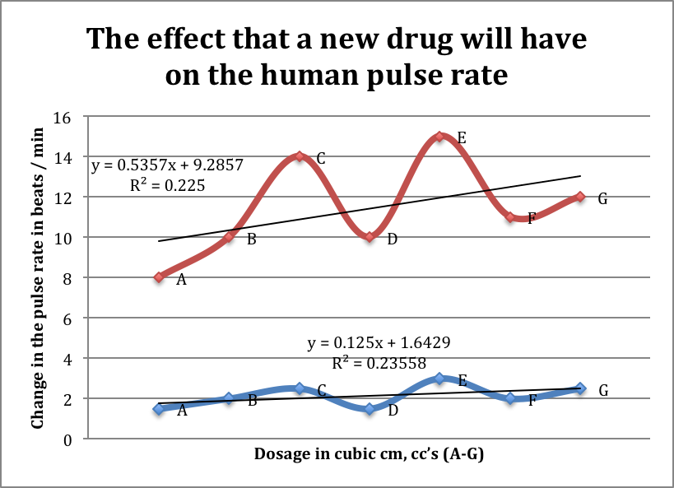

Patient | A | B | C | D | E | F | G
Dosage in cubic cm, cc’s | 1.5 | 2 | 2.5 | 1.5 | 3 | 2 | 2.5
Change in the pulse rate in beats/min | 8 | 10 | 14 | 10 | 15 | 11 | 12

Dosage CC's | Change in pulse rate
0 | 9.3
1 | 9.8
3.5 | 11.2
6 | 12.5

We have the dosage on the horizontal axis because our independent variable is the dosage. It is the variable in which we are changing, while we are attempting to view how changing the dosage relates to the patient’s change in pulse rate. I would say that these estimations might lead to inaccurate results if tested clinically. If you look at the regression line for patient E, there is a significant spike. Also, we have no data on any dosage higher than 3.0.

These next problems are similar or identical to problems from assignment 11. For each problem, create a line graph (remember to use the scatterplot option) illustrating the population growth/decline. Be sure to label each graph appropriately.

Problem 11.4

The population of a country is currently 4.3 million, and it is growing at an annual rate of 1.25%. Assuming it continues growing at this rate,

a) what will its population be in the year 2019?

b) what will its population be in the year 2034?

c) When will the population reach 7 million?

year | population
2013 | 4,300,000
2014 | 4,353,750
2015 | 4,408,172
2016 | 4,463,274
2017 | 4,519,065
2018 | 4,575,553
2019 | 4,632,748
2020 | 4,690,657
2021 | 4,749,290
2022 | 4,808,656
2023 | 4,868,765
2024 | 4,929,624
2025 | 4,991,244
2026 | 5,053,635
2027 | 5,116,805
2028 | 5,180,765
2029 | 5,245,525
2030 | 5,311,094
2031 | 5,377,483
2032 | 5,444,701
2033 | 5,512,760
2034 | 5,581,670
2035 | 5,651,440
2036 | 5,722,083
2037 | 5,793,610
2038 | 5,866,030
2039 | 5,939,355
2040 | 6,013,597
2041 | 6,088,767
2042 | 6,164,876
2043 | 6,241,937
2044 | 6,319,962
2045 | 6,398,961
2046 | 6,478,948
2047 | 6,559,935
2048 | 6,641,934
2049 | 6,724,958
2050 | 6,809,020
2051 | 6,894,133
2052 | 6,980,310
2053 | 7,067,564
2054 | 7,155,908
2055 | 7,245,357

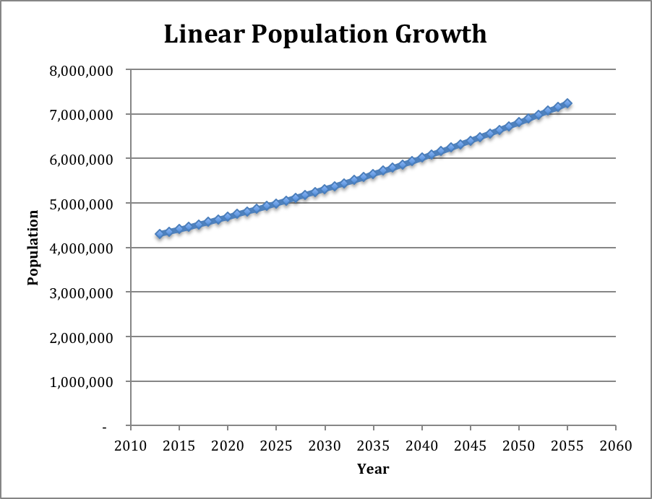
a). 4,632,748
b). 5,581,670
c). 2053

Problem 11.5

Suppose the population of a city is 800,000. If the population is growing at an annual rate of 3%,

a) What will the population be in 10 years?

b) What will it be in 25 years?

c) How long will it take for the population to reach 3 million?

year | population
2013 | 800,000
2014 | 824,000
2015 | 848,720
2016 | 874,182
2017 | 900,407
2018 | 927,419
2019 | 955,242
2020 | 983,899
2021 | 1,013,416
2022 | 1,043,819
2023 | 1,075,133
2024 | 1,107,387
2025 | 1,140,609
2026 | 1,174,827
2027 | 1,210,072
2028 | 1,246,374
2029 | 1,283,765
2030 | 1,322,278
2031 | 1,361,946
2032 | 1,402,805
2033 | 1,444,889
2034 | 1,488,236
2035 | 1,532,883
2036 | 1,578,869
2037 | 1,626,235
2038 | 1,675,022
2039 | 1,725,273
2040 | 1,777,031
2041 | 1,830,342
2042 | 1,885,252
2043 | 1,941,810
2044 | 2,000,064
2045 | 2,060,066
2046 | 2,121,868
2047 | 2,185,524
2048 | 2,251,090
2049 | 2,318,623
2050 | 2,388,181
2051 | 2,459,827
2052 | 2,533,622
2053 | 2,609,630
2054 | 2,687,919
2055 | 2,768,557
2056 | 2,851,613
2057 | 2,937,162
2058 | 3,025,277
2059 | 3,116,035
2060 | 3,209,516

- 1,075,133
- 1,675,022
- 46 years.

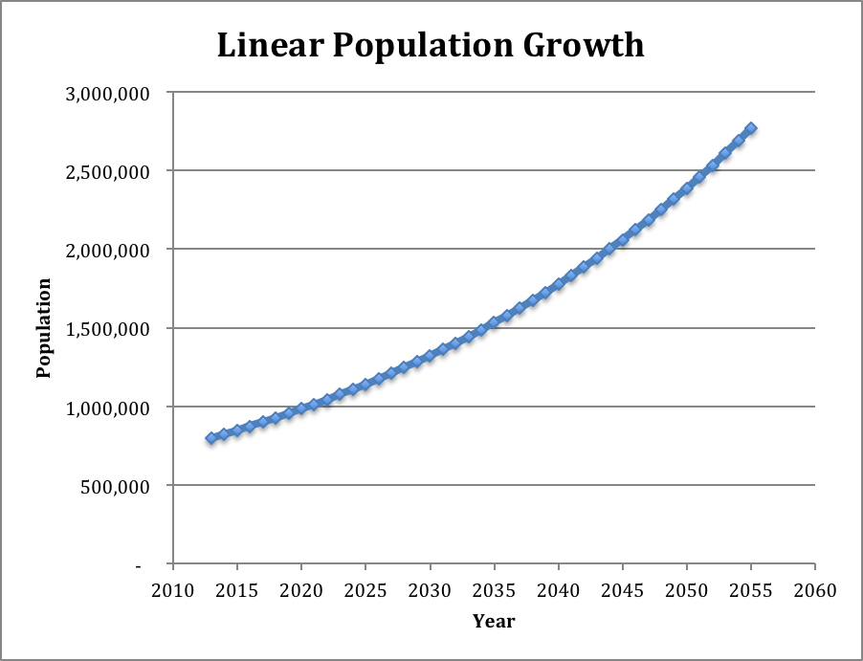

Problem 11.6

Suppose that the population of an endangered species is 25,000. If the population is decreasing at an annual rate of 6.5%,

a) What will it be in 10 years?

b) What will it be in 25 years?

c) How long will it take for the population to reach 3,000?

- 12,766
- 4,658
- 32 years

year | population
2013 | 25,000
2014 | 23,375
2015 | 21,856
2016 | 20,435
2017 | 19,107
2018 | 17,865
2019 | 16,704
2020 | 15,618
2021 | 14,603
2022 | 13,654
2023 | 12,766
2024 | 11,936
2025 | 11,160
2026 | 10,435
2027 | 9,757
2028 | 9,123
2029 | 8,530
2030 | 7,975
2031 | 7,457
2032 | 6,972
2033 | 6,519
2034 | 6,095
2035 | 5,699
2036 | 5,329
2037 | 4,982
2038 | 4,658
2039 | 4,356
2040 | 4,072
2041 | 3,808
2042 | 3,560
2043 | 3,329
2044 | 3,112
2045 | 2,910

